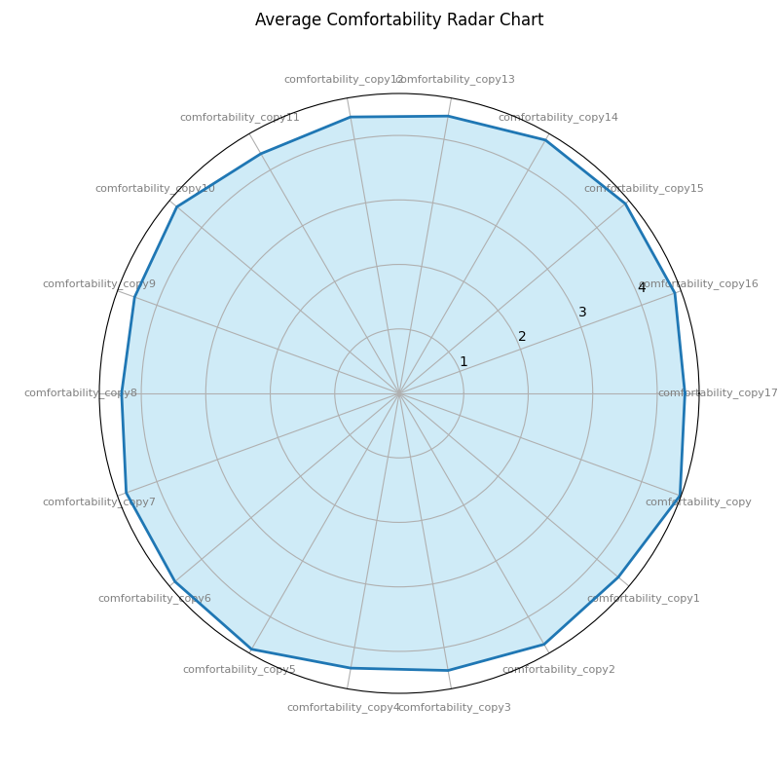

The GGHN HIV treatment program is achieving remarkable success, with maximum scores in staff respect (dimension 15), confidentiality (dimension 16), and psychosocial support (dimension 17). Given the cultural challenges in northern Nigeria, this is a significant accomplishment. While minor issues with waiting times (dimensions 8, 9, and 11) exist, scoring 3.7, overall patient satisfaction remains high. The program's strengths include high-quality services, client satisfaction, and strong retention rates, demonstrating effective health system strengthening and cultural understanding across three states. This success is likely to positively impact treatment adherence, community engagement, and reduce loss to follow-up, making the program a model for effective HIV service delivery in challenging environments.

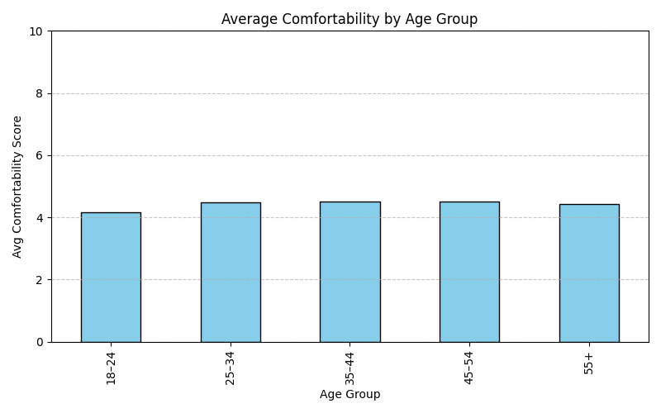

From the plot

Age group 35–44 had the highest average comfort score of 4.51

Followed by 45–54 with 4.49, and 25–34 with 4.46

55+ scored 4.42, while 18–24 had the lowest at 4.16

This shows comfortability generally increases with age, peaking at 35–44, then slightly declining. Younger respondents (18–24) reported the least comfort. Suggests younger individuals may feel more discomfort or have higher expectations. Targeted interventions or communication may be needed for this group.

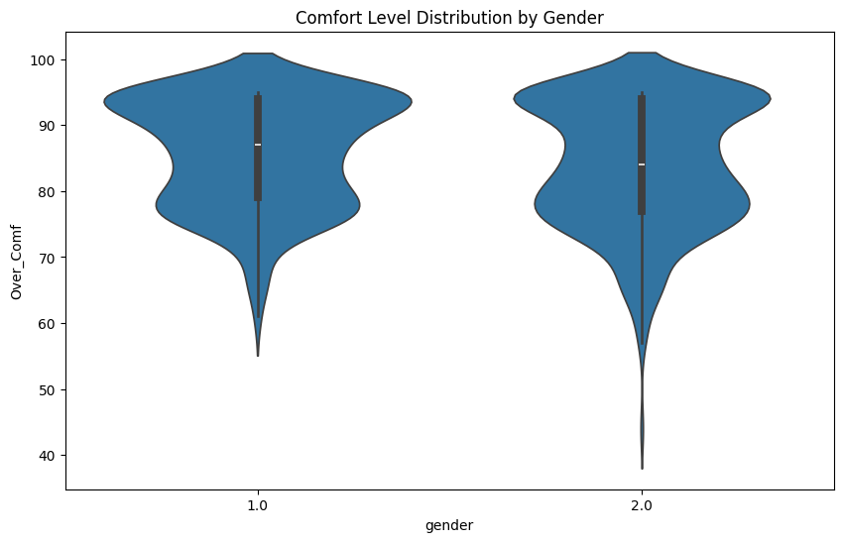

The comfort scores are concentrated in the upper range of 80-100, with median scores clustering around 85-90 for both males and females. Approximately 80% of respondents from both genders experience high comfort levels. The interquartile ranges show minimal variation between males and females, with 50% of each group scoring within a narrow band of high satisfaction levels. Less than 5% of both male and female respondents report comfort levels below 70. The gender parity index approaches 1.0, indicating near-perfect equity in service delivery outcomes.

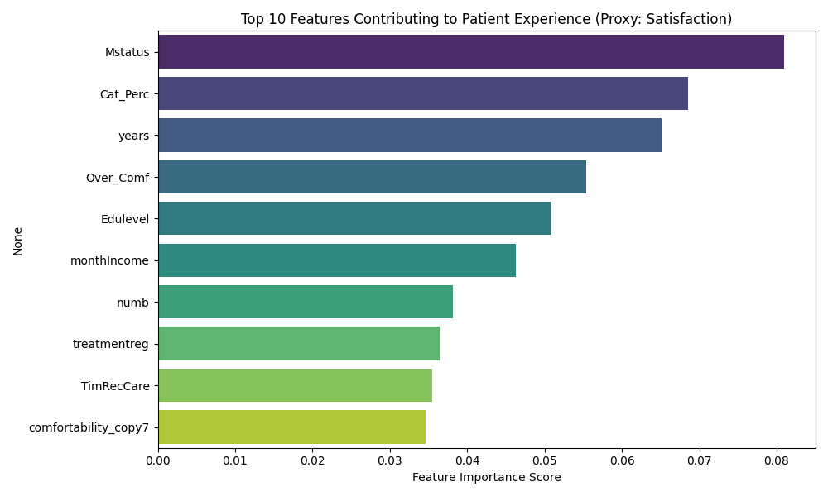

Marital status had the highest impact on experience score (0.081), suggesting relationship status strongly influences patient satisfaction and support. Perception category (0.069) showed how clients viewed care quality, directly tied to their overall experience. Age (0.065) influenced maturity in managing HIV care. Overall comfort (0.055) captured how safe and respected patients felt. Education level (0.051) pointed to health literacy and ability to navigate care. Monthly income (0.046) reflected affordability and financial ease in accessing services. Number of household members (0.038) indicated support burden or caregiving dynamics. Treatment regimen (0.036) shaped how convenient or tolerable clients found the medication. Time to receive care (0.035) measured system responsiveness after diagnosis. Specific comfort indicator (0.035) reinforced that nuanced aspects like respect or privacy matter in patient experience. These top 10 features are directly tied to the evaluation's objective of assessing person-centered care, client satisfaction, and health outcomes.

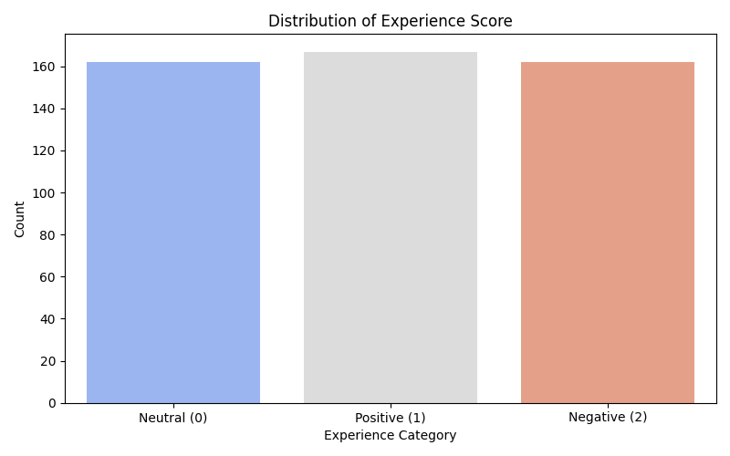

A predictive analysis was conducted on the dataset, including extensive feature engineering, to derive an experience score variable from key indicators such as marital status, perception category, years in care, income, education level, treatment regimen and other comfort related factors. The experienced score was categorized into three levels to reflect the quality of patient experience within the HIV treatment program: Negative (1), Neutral (0), and Positive (2)

The participant group for the negative experience had the highest count (167), indicating that a significant portion of clients reported poor or dissatisfying experiences during care, highlighting issues in service delivery and patient engagement

162 patients had a neutral experience and this suggests an average or inconsistent experience that is, not bad enough to be negative but not positive enough to inspire satisfaction or trust

Also nearly equal in size to the neutral group, 162 patients showed a promising segment of the population that has a good experience, likely influenced by timely service and comfort levels.

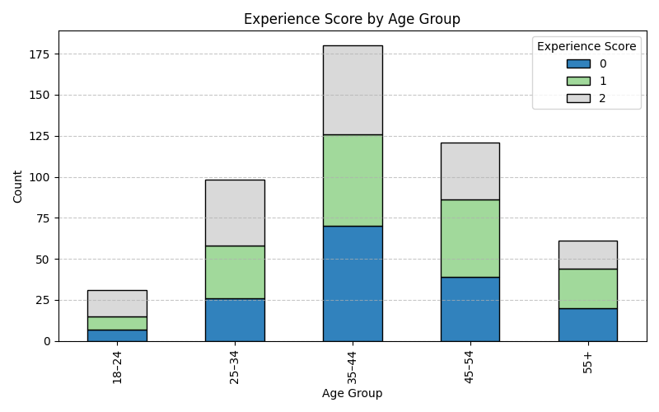

The 35–44 age group has the highest total responses (180), with Neutral scores leading (70).

The 25–34 group shows more positive experiences (40) than negative or neutral.

The 18–24 group, although smaller in count, has a higher proportion of positive experiences (16 out of 31 total).

Experience tends to be more varied in middle age ranges (35–44 and 45–54), suggesting diverse feedback.

Older respondents (55+) lean more towards neutral and negative, with relatively fewer positive scores.

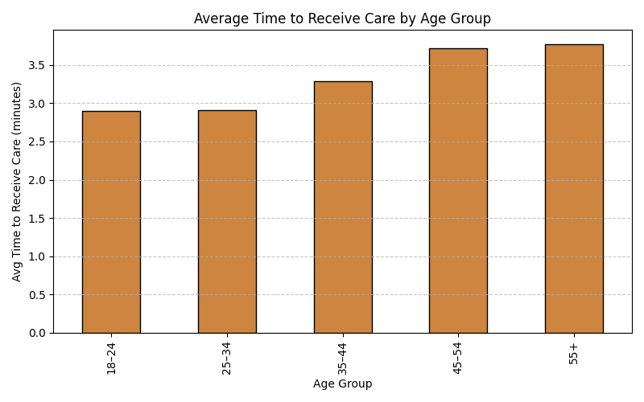

From the average time to receive care by age group, the data shows:

Younger individuals (18–34) receive care more promptly (avg ~2.9), indicating better access or fewer delays.

As age increases, the time to receive care also increases — especially from age 35 upward, peaking in the 55+ group (avg ~3.77).

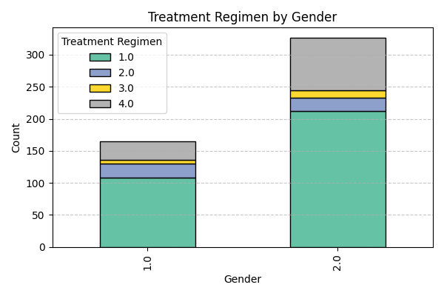

Male (gender = 1):

108 are on first-line regimen

22 are on second-line

6 are on third-line

29 are not sure of their regimen

Female (gender = 2):

212 are on first-line regimen

21 are on second-line

11 are on third-line

82 are not sure of their regimen

Majority of both genders are on first-line treatment, but females significantly dominate (212 vs 108).

A large number of females (82) are not aware of their regimen, compared to males (29). This may signal a communication or awareness gap among women in understanding their treatment.

Across both genders, progression to second and third-line regimens is relatively low, indicating either effective first-line performance or limited transitions.